

**THE UNIVERSITY OF BUEA**

**FACULTY OF ENGINEERING AND TECHNOLOGY**

**DEPARTMENT OF COMPUTER ENGINEERING**

**CEF 440: INTERNET PROGRAMMING AND MOBILE PROGRAMMING**

**Group 22**

**TASK 5: UI Design and Implementation**

|  |  |  |
| --- | --- | --- |
| **Name** | **Matricule** | **Option** |
| 1. Enow Myke-Austine Eta | FE21A183 | Software |
| 1. Mokfembam Fabrice Kongnyuy | FE21A240 | Software |
| 1. Ndangoh Boris Bobga | FE19A072 | Network |
| 1. Ndong Henry Ndang | FE21A248 | Software |
| 1. Niba Verine Kajock | FE21A267 | Network |
| 1. Takem Jim-Rawlings E. | FE21A309 | Software |

**COURSE INSTRUCTOR:**

**Dr. NKEMENI VALERY**

Contents

I. INTRODUCTION 2

II. DESIGN PRINCIPLES 2

III. UI DESIGN 4

i. User Personas: 4

ii. Wire Framing 4

iii. Mockup and Visual Design 5

IV. UI IMPLEMENTATION 17

V. COMPLIANCE AND ACCESSIBILITY CONSIDERATIONS 18

# INTRODUCTION

A well-designed user interface (UI) is critical for the success of any disaster management system (DMS). During emergencies, clear communication and efficient user interactions are very important. An effective UI empowers users, from emergency responders to the general public, to access vital information, report situations, and take necessary actions quickly.

This document details the UI design and implementation process for our DMS. We prioritized creating a user-centered interface that aligns with the various stages of the Disaster Management Lifecycle (DMLC). Our focus encompassed both functional and non-functional requirements, ensuring the system fulfills its core functionalities while remaining accessible and adaptable to diverse user needs and environments.

The UI design adheres to the overall system architecture, guaranteeing seamless integration and data flow between different components of the DMS. This comprehensive approach ensures a robust and user-friendly platform that can effectively support preparedness, response, recovery, and mitigation efforts throughout the disaster lifecycle.

In the context of our disaster management system, the UI design and implementation serves as the point of interaction between users and the system, facilitating crucial tasks such as receiving real-time alerts, reporting incidents, request for help, accessing emergency resources (e.g. guides), and communicating with authorities. Therefore, a carefully crafted UI is essential to ensure that users can effectively navigate through these functionalities, even under challenging circumstances.

# DESIGN PRINCIPLES

User interface design principles guide the creation of interfaces that are visually appealing, user-friendly, and functional. In the context of our disaster management system, adhering to these principles ensures that the UI effectively supports users in navigating through critical information and functionalities, contributing to a seamless user experience.

* **Color Theme (#1e7fdb shade of Royal Blue)**:

The chosen color theme for our UI is a shade of blue, specifically #1e7fdb. Blue was chosen for its relation to safety, trust, and reliability, making it particularly suitable for a disaster management system. It instills a sense of calmness and reassurance, which is crucial during emergency situations. Additionally, we implemented both light and dark mode options to accommodate users' preferences and improve visibility in different lighting conditions.

* **Typography (SF Pro Display)**:

We opted for the SF Pro Display font family to give our UI a native feel, ensuring consistency with modern operating systems and enhancing readability. SF Pro Display offers a clean and professional appearance, making it suitable for conveying important information and instructions effectively. Furthermore, using a widely recognized font family enhances familiarity for users, contributing to a more intuitive user experience.

* **Iconography**:

Icons are strategically used throughout the app to represent different disaster types and improve usability. By incorporating visually distinctive icons, users can quickly identify and differentiate between various types of emergencies, facilitating faster decision-making and response. Additionally, icons help conserve screen space and reduce textual clutter, making the UI more visually appealing and user-friendly.

* **Images**:

We utilized 3D images to provide a more immersive and engaging experience for users. By using 3D images, we create a sense of depth and realism, which enhances the overall visual appeal and cleanliness of the UI. Furthermore, carefully selected images help convey information more effectively, improving comprehension and user engagement.

 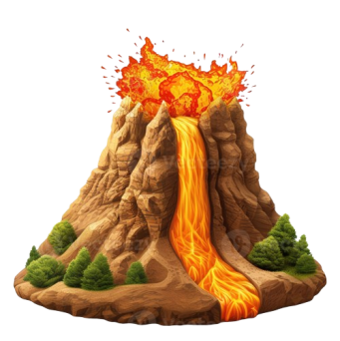 

Sample 3D Images

By adhering to design principles such as color consistency, typography selection, strategic use of iconography, and incorporation of images, particularly 3D images, ensures that our UI is visually appealing, intuitive, and functional. By prioritizing these design elements, we enhance the user experience and contribute to the effectiveness of our disaster management system.

# UI DESIGN

In this section we dive into the core UI components, screen layouts, and functionalities designed to meet the diverse needs identified throughout the user research and system planning phases. We start by identifying our various user personas then designing the various screen to meet the identified personas.

## User Personas:

From our system design, we identified three key user personas for the disaster management system (DMS):

* **Users (General Public):** These are individuals potentially affected by disasters. They require access to real-time alerts, emergency instructions, shelter locations, and also incident reporting.
* **Volunteers**: This group comprises individuals willing to contribute their time and skills during disasters. The UI will provide them with clear instructions on volunteering opportunities, and task assignments.
* **Emergency Responders**: This group includes professionals trained to handle emergencies (firefighters, medical personnel, NGO, Government bodies etc.). Their UI needs to be efficient and provide quick access to critical information such as incident reports and also incident validation. The design should prioritize speed, accuracy, and functionalities that support effective response strategies.

1. Wire Framing:

By understanding the specific needs and goals of each user persona, we were able to tailor the UI design to provide an optimal experience for all stakeholders involved in disaster management. We later identified the various pages and moved to the wireframing.

The wireframe gives a visual representation of the various pages, typically created with basic shapes, lines, and placeholder text. It outlines the page structure, information hierarchy, and user flow without any visual distractions. For our system, we used the paper and pen method for drawing our wireframes.

Here are some examples of the types of screens that were wireframed for the DMS:

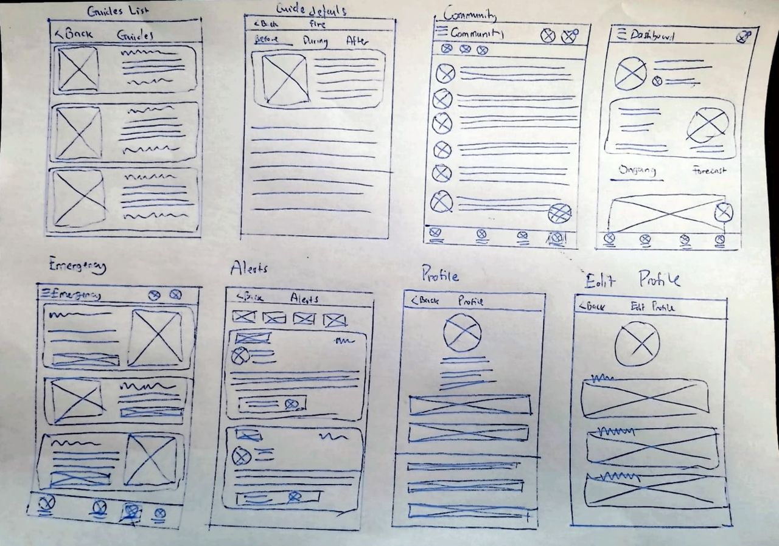

(include image of some few wireframes here)

1. Mockup and Visual Design:

Having established a solid foundation with design principles, wireframing, and a focus on core functionalities, we transitioned into the mockup and visual design phase for the disaster management system (DMS) UI.

Our goal was to transform the wireframes into visually appealing and user-friendly interfaces that effectively guide users through critical actions and information access during disasters.

Below are the various pages, the user personas involved, and the functionality it addresses, starting with the various user pages:

**Users (General Public) Pages:**

1. **Home**: this page provides current location weather and allows switching between preferred locations. It also displays data about ongoing and potential disasters.

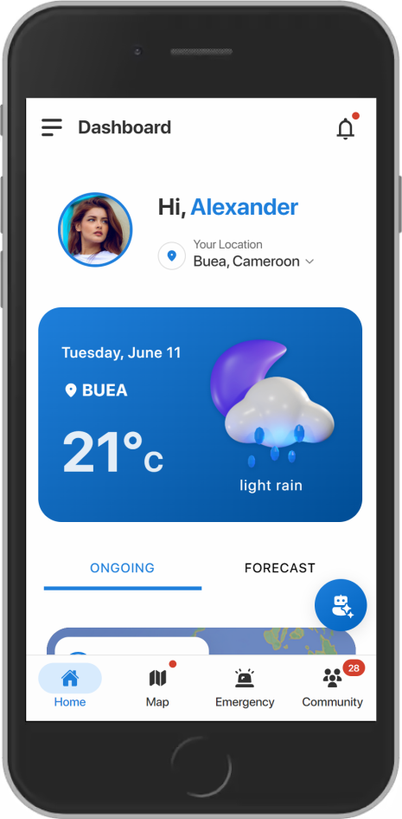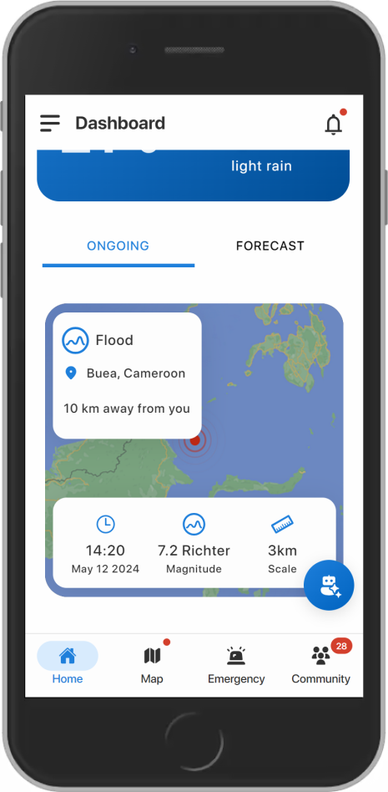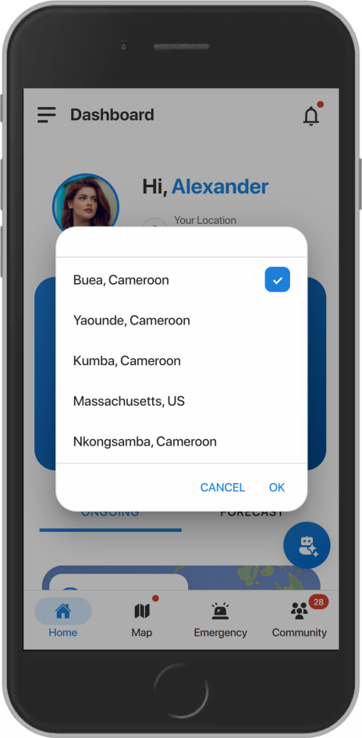

Fig: Home Page

1. **Map**: here, users can view disasters around them and choose to see details about a specific disaster and also integrate evacuation routes and geospatial data (e.g., shelters, affected areas) for the chosen disaster.

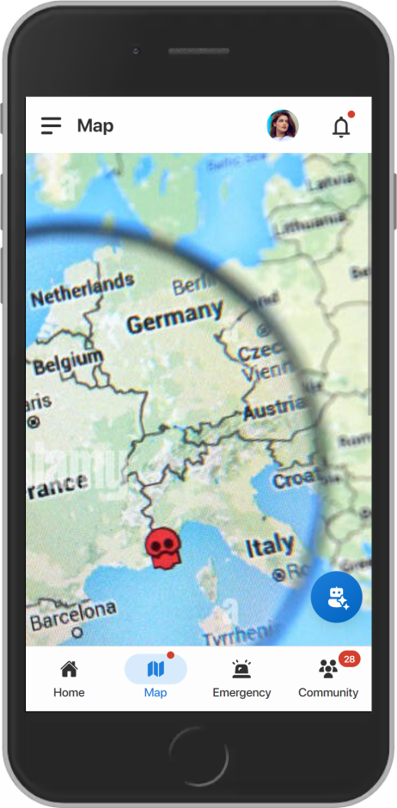

Fig: Map Page

1. **Emergency Page**:

**Emergency Numbers**: Provides access to emergency responders phone numbers.

Report Disaster & Request Help: This section can be further refined:

**Consolidate "Report Disaster" and "Request Help" based on context:** If the user triggers this section from the map while viewing a disaster, prioritize reporting that specific disaster. If triggered from the main menu, offer options for reporting a new disaster or requesting help (e.g., medical aid, transportation).

**Step-by-Step Report Process**: We sought to make the report disaster a captivating and enjoyable process, so we used an onboarding screen with clear instructions to guide users through reporting a disaster. This makes it user-friendly and encourages accurate information gathering.

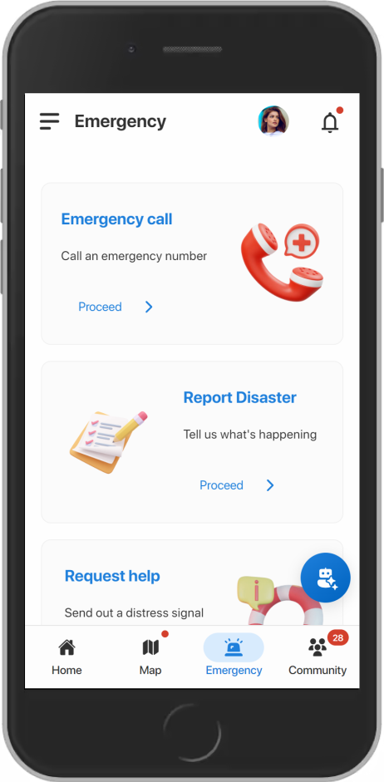 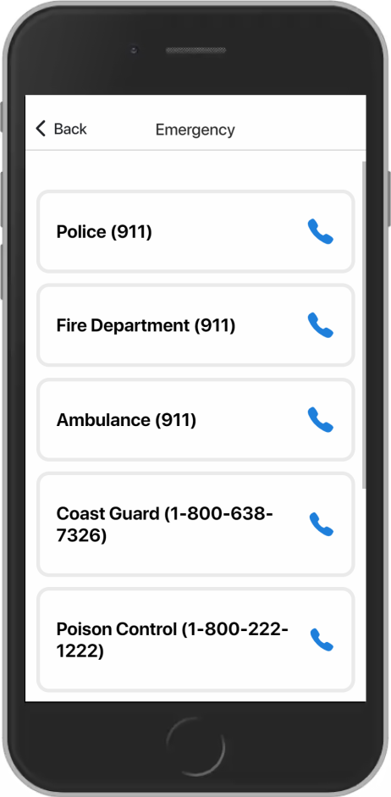 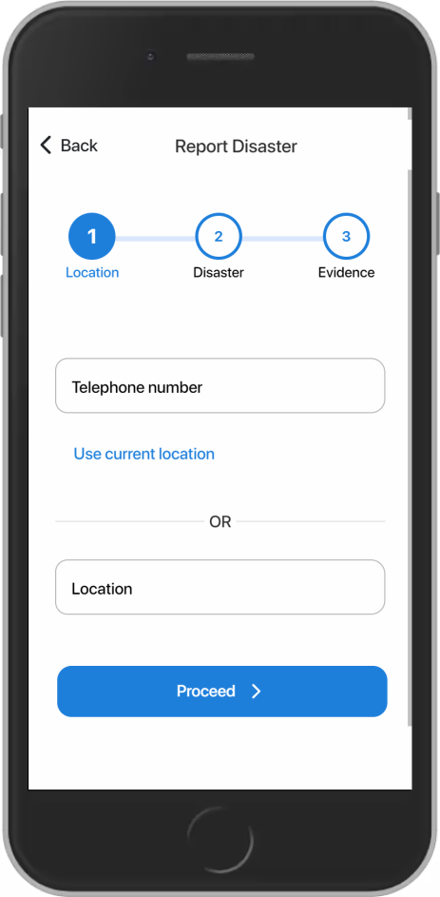

Fig: Emergency Page, Emergency Call, Report Disaster

1. **Community**:

This page contains separate chat rooms for users and responders to connect within their respective groups and also responders can create both public and private chat rooms, depending on the situation's needs.

This helps users and responders post topics, share updates, and ask questions within a broader context and also create dedicated chat rooms for specific disasters, allowing focused collaboration and discussion.

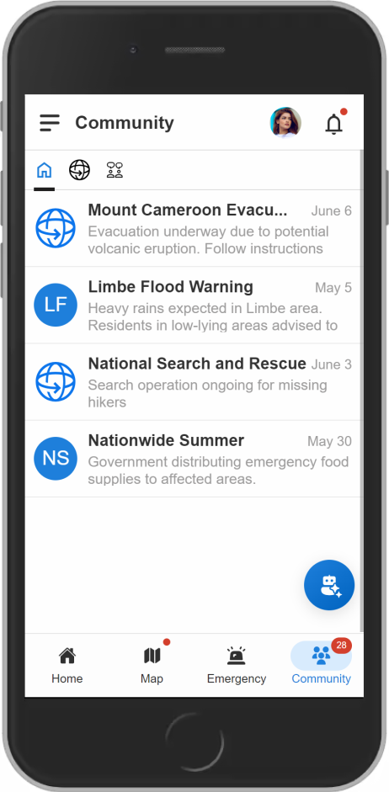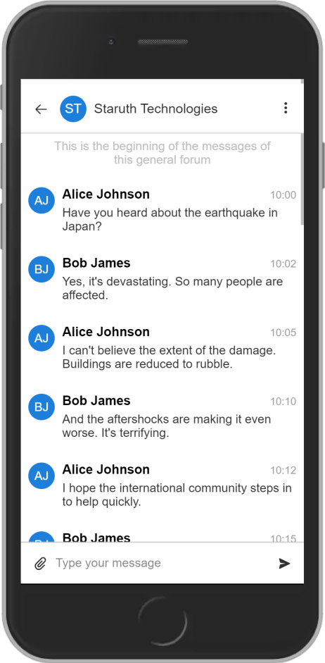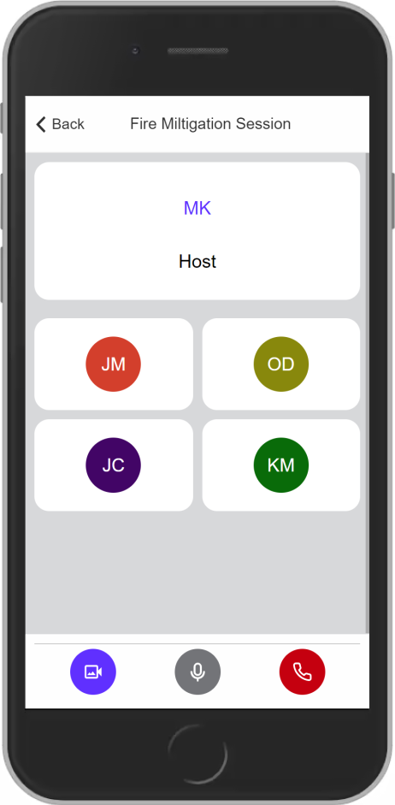

Fig: Community Forums and Chat Rooms

1. **Assistant**: The Assistant Page serves as a AI-driven helper to provide users with meaningful insights and assistance related to disasters.

**The users can prompt the AI with disaster related questions and get the valuable response which helps them to enhance their knowledge on these disasters and thereby increasing community resilience.**

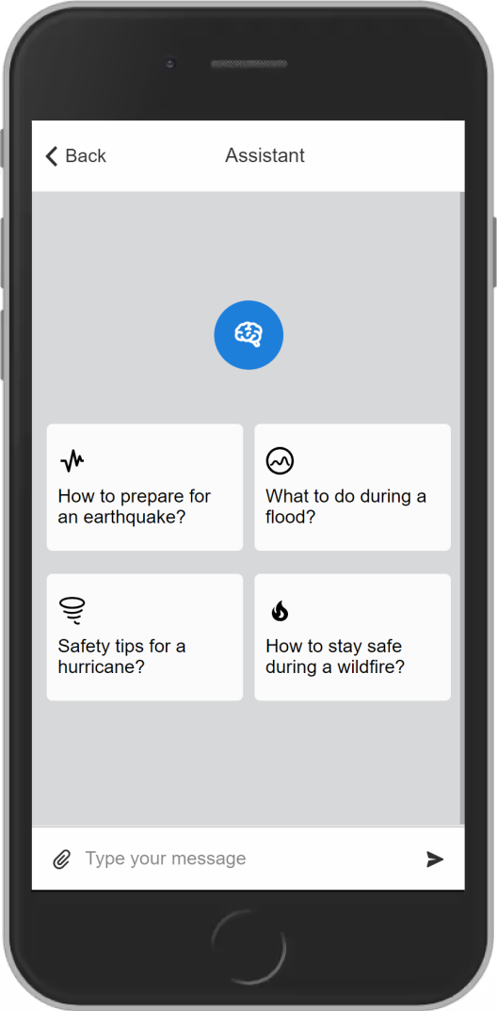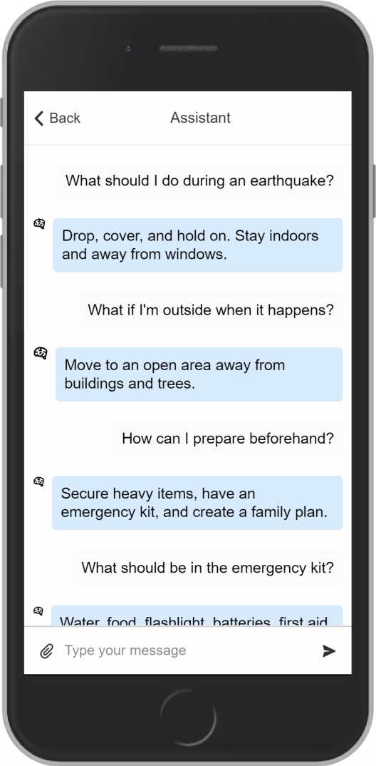

Fig: Assistant Page

1. **Alerts Page:**

The Alerts page displays a list of ongoing disasters with detailed information, including their status, start time, duration, and affected areas. Users can click on each disaster to view additional details and access geospatial data, such as affected areas and evacuation routes, on an interactive map.

Each disaster can be viewed on the map, which will contain geospatial data (affected area, evacuation routes, etc.) about that disaster, allowing users to visualize the extent of the disaster and plan accordingly.

It will provide real-time alerts about disasters and their status, including potential, ongoing, and already occurred disasters. It displays information such as when the disaster started, its duration, and its current status.

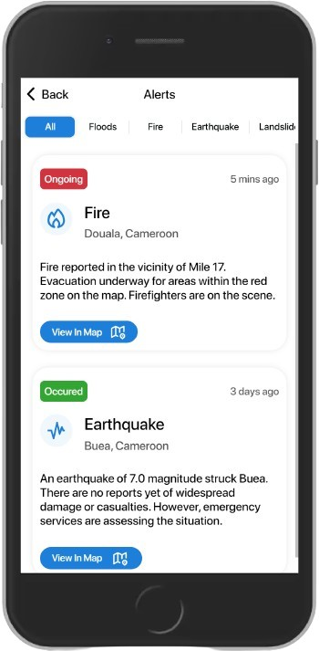

Fig: Alerts Page

1. **Guides Pages:**

This page will contain guides about various disasters and how users can respond or behave in the occurrence of a disaster. Each guide provides crucial information on how to prepare, respond effectively, and recover safely in the event of a disaster.

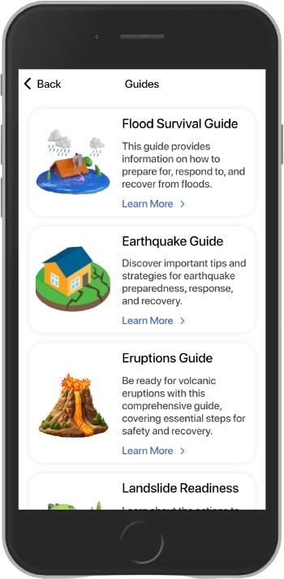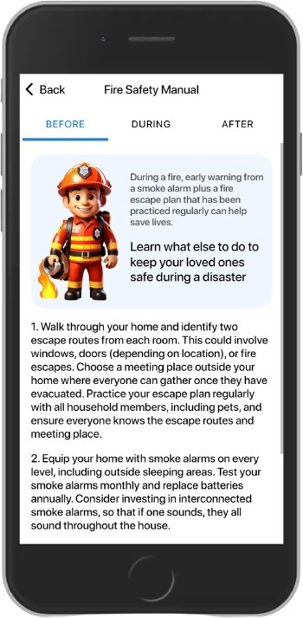

Fig: Guide and Guide Content Page

1. **Profile Page:**

This page displays the user profile with his various details e.g. name, email, and phone number. Here he can add or remove preferred location, edit his profile, volunteer, request help and support, logout and delete account. On the edit profile page he can edit his profile in case his details change, but he has to first authenticate using his password before being allowed to perform an edit.

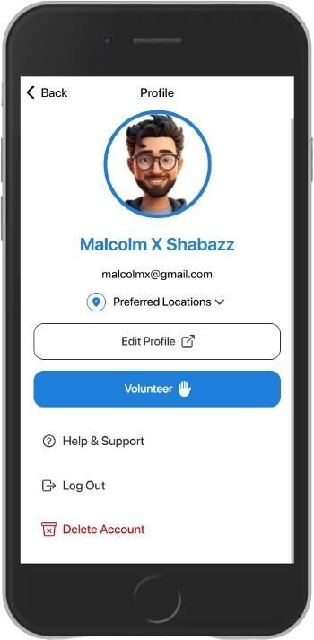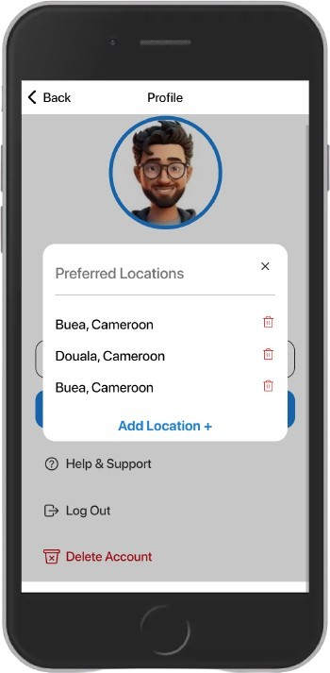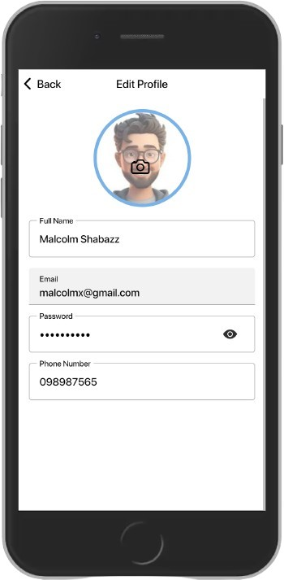

Fig: Profile Page, add Preferred Locations, and edit profile page

1. **Announcements**: Display announcements from both responders and the system (e.g., official updates, safety tips) within a single feed.

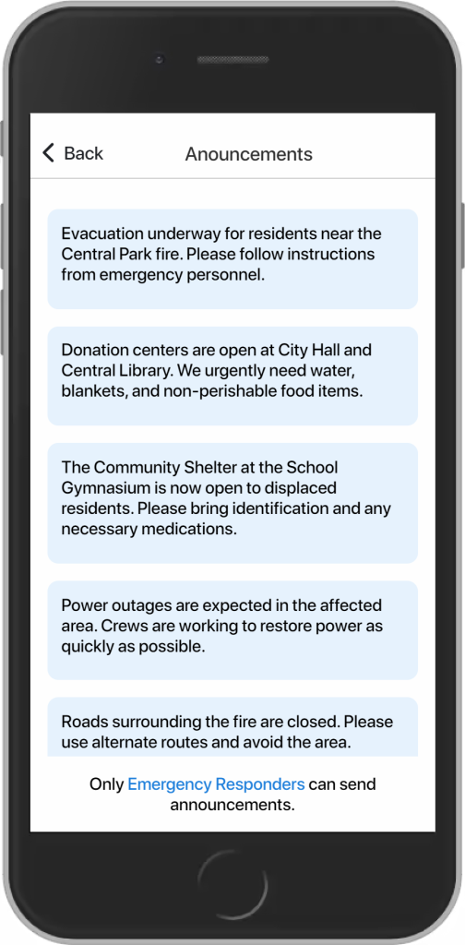

Fig: Announcements Page

1. **Login & Register:**

Here, users authenticate themselves to access personalized features and data, and also create user accounts by collecting necessary info.

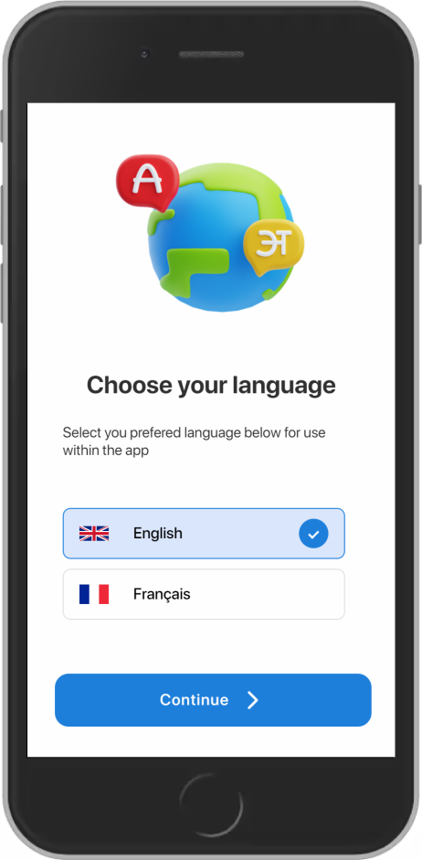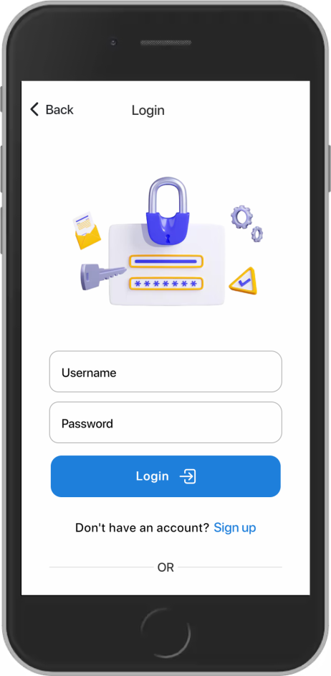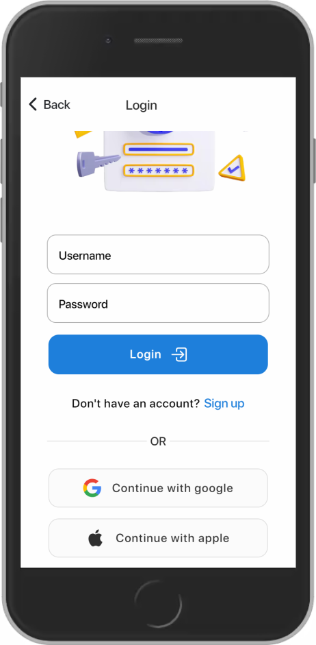

Fig: Select Language page, and login page

**Emergency Responders Pages:**

1. **Report a Disaster:** Responders can create new disaster entries in the system, triggering alerts and notifying relevant parties.
2. **Public Announcements:** This section allows responders to broadcast general information, updates, or advisories related to disasters or preparedness measures.

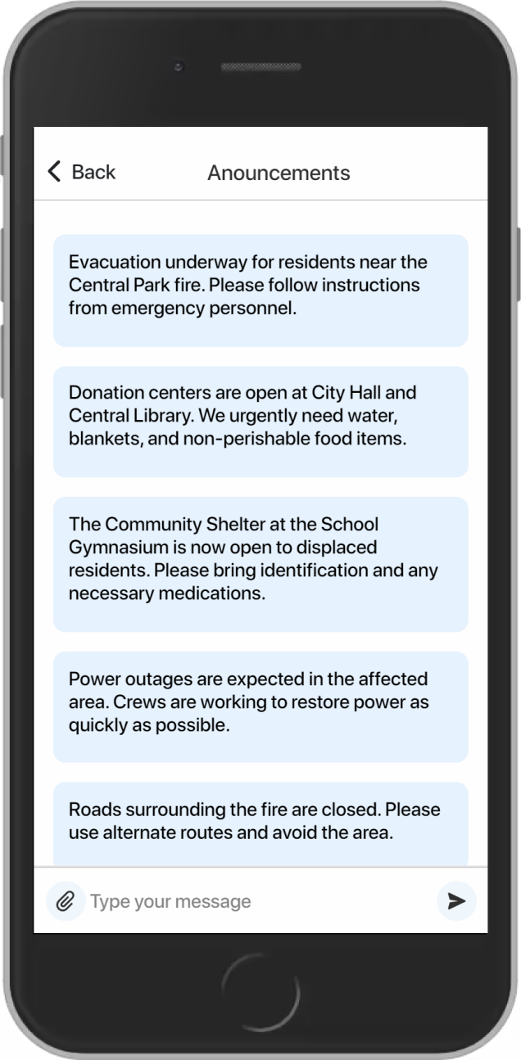

Fig: Announcements Page

1. **Disaster Alert Management:**
   * **Validate Reports:** Responders can verify user-reported disasters, confirming their occurrence or ongoing nature. This helps distinguish genuine emergencies from false alarms.
   * **Update Disaster Status:** After validation, responders can update the status of a disaster (e.g., from "Ongoing" to "Occurred" or "Potential").

**Alert Categories:**

* **Pending:** These alerts are user-reported incidents awaiting verification by a responder.
* **Detected:** Alerts received from external sources (e.g., APIs) that may require further investigation or confirmation.
* **Reported & Validated:** These alerts have been reported by users and confirmed by a responder, indicating a verified incident

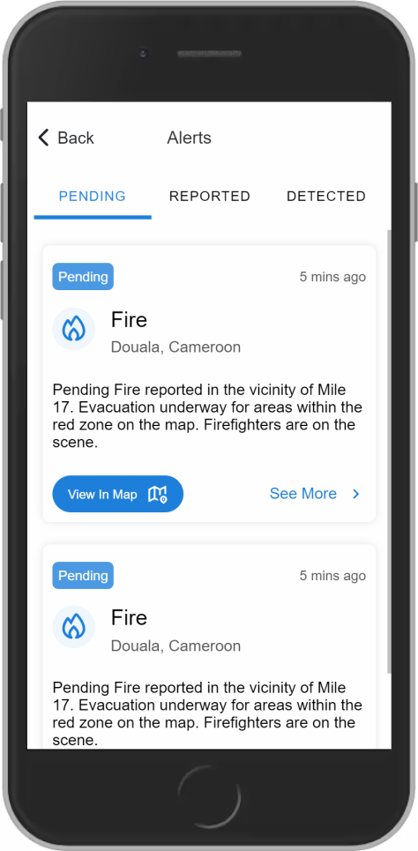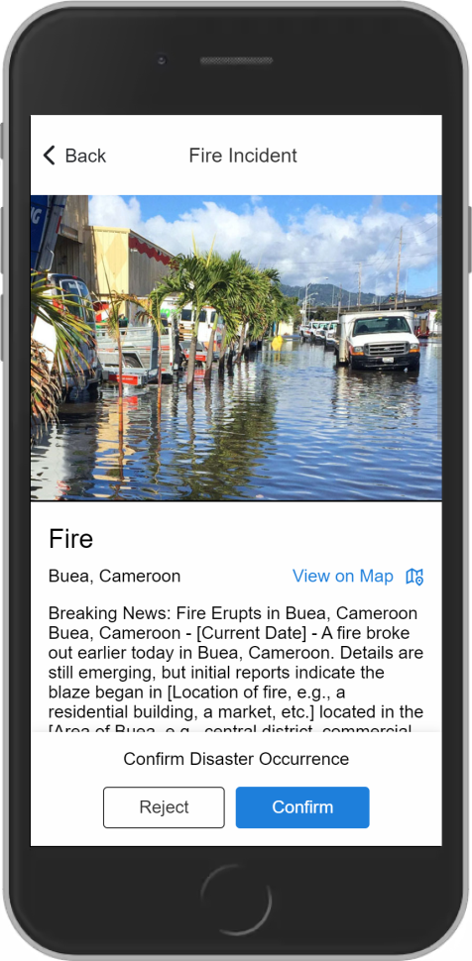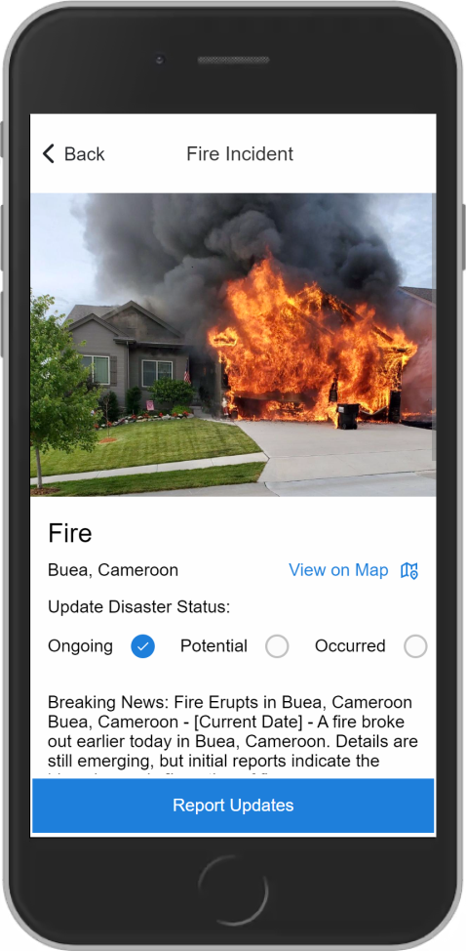

Fig: Responders Alerts page, Validate Disaster Occurrence, and Update Disaster Status

# UI IMPLEMENTATION

* **Technologies Used**: For I UI implementation, we used Ionic with React TypeScript for the following reasons:
* Ionic offers a vast library of pre-built UI components like input, button, actions, lists etc. This makes the development faster by providing a foundation for building a user-friendly and consistent interface that adheres to design principles.
* Write Once, Run Everywhere: A significant advantage of Ionic is its ability to create a single codebase that functions seamlessly across web browsers, Android, and iOS devices. This approach reduces development time and maintenance efforts as you don't need to create separate codebases for each platform.
* Component-based Architecture: Building the UI with React components promotes code reusability and maintainability. Complex functionalities can be broken down into smaller, reusable components.
* Improved State Management: React's state management features simplify handling dynamic UI elements and data flow within the application.
* Type Safety with TypeScript: TypeScript adds static type checking to the JavaScript codebase. This improves code readability, maintainability, and helps catch potential errors early in the development process.
* **Version control with GitHub**: The project source code was managed using Git and hosted on GitHub, allowing for collaborative development and version control.

Branches were created for feature development, and pull requests were used for code review and collaboration among team members

# COMPLIANCE AND ACCESSIBILITY CONSIDERATIONS

Compliance and accessibility considerations are crucial aspects of designing a system. Compliance ensures that the system adheres to all relevant laws, regulations, and standards, such as the ISO standards, which can include everything from data security to business continuity planning. This helps ensure the system is robust, reliable, and capable of effectively performing as required. On the other hand, accessibility ensures that the system is usable by all individuals, including those with disabilities or other access needs. This is particularly important in a disaster management context, as disasters can affect anyone, and it’s crucial that everyone is able to access the information and resources they need to stay safe. Therefore both compliance and accessibility are key to creating a disaster management system that is effective, inclusive, and trusted by the community it serves.

The choice of using the Ionic framework for developing the disaster management application was also influenced by its robustness to cater for compliance and accessibility considerations.

Ionic takes compliance guidelines into consideration when developing its framework and components. Here are some of the key compliance areas that Ionic addresses:

1. **Security Best Practices:** Ionic follows industry-leading security best practices, such as regular security audits and penetration testing. This helps to protect disaster management applications from vulnerabilities and ensures that user data is kept safe.
2. **Compliance Certifications:** Ionic has obtained compliance certifications for various standards, including ISO 27001 (Information Security Management) and ISO 27701 (Privacy Information Management). These certifications demonstrate Ionic's commitment to compliance and provide assurance to organizations that their disaster management applications will meet regulatory requirements
3. **GDPR (General Data Protection Regulation):** Ionic provides support for building applications that adhere to the GDPR's guidelines for data privacy and protection, which is crucial for applications used in the European Union and other regions with similar data privacy laws.
4. **PCI DSS (Payment Card Industry Data Security Standard):** For applications that handle payment card information, Ionic offers guidance and best practices to help developers build components and functionality that comply with PCI DSS requirements.
5. **FISMA (Federal Information Security Management Act):** Ionic's framework and components are designed to support the security and risk management controls required by FISMA, which is important for applications used in the U.S. federal government.
6. **ADA (Americans with Disabilities Act):** As mentioned earlier, Ionic's accessibility features and compliance with standards like WCAG and Section 508 help ensure applications built with Ionic are accessible and compliant with the ADA.

Furthermore, Ionic has made a strong commitment to accessibility and strives to ensure its framework and components adhere to various accessibility guidelines and standards, such as:

1. **WCAG (Web Content Accessibility Guidelines):** Ionic aims to follow the WCAG 2.1 guidelines, which provide a comprehensive set of recommendations for making web content more accessible to people with disabilities.
2. **Section 508:** Ionic ensures its components and framework are compliant with the requirements of Section 508 of the Rehabilitation Act, which mandates that electronic and information technology developed, maintained, or used by the U.S. federal government be accessible to people with disabilities.
3. **Keyboard Accessibility:** Ionic components are designed to be fully keyboard-accessible, allowing users to navigate and interact with the application using only a keyboard.
4. **Screen Reader Support:** Ionic components provide proper ARIA (Accessible Rich Internet Applications) attributes and roles, enabling screen readers to accurately interpret and convey the content and functionality to users.
5. **Color Contrast:** Ionic pays attention to the color contrast of its components, ensuring that text and UI elements meet the minimum contrast ratio requirements for accessibility. For example, Ionic utilizes high contrast themes to improve visibility for users with low vision. This makes it easier for users to distinguish between different elements on the screen, and can reduce eye strain.
6. **Accessibility Testing:** Ionic incorporates accessibility testing into its development and review processes, using tools like Axe and manually testing with assistive technologies to identify and address any accessibility issues.
7. **Localization and Translation:** Ionic supports localization and translation, making applications accessible to users who speak different languages. This is important for disaster management applications, which may need to be used by people from all over the world.